

The circuit diagram for 120º mode is shown in Fig. 3.23 (a) which is the same as Fig. 3.20 (a) for 180 º mode. Here, in this type of control, each switch conducts for 120º, with only two switches remaining on in any of the 6 sub-intervals of 60º. The gating signals are shown in Fig. 3.23 (b) from which it can be inferred that the conduction sequence of the switches is 61, 12, 23, 34, 45, 56 in intervals I, II, III, IV, V & VI respectively.

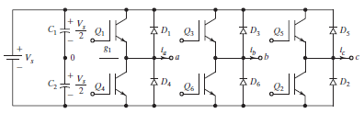

**(a) Circuit**

**Fig. 3.23 Three phase 6 step 120 mode bridge inverter**

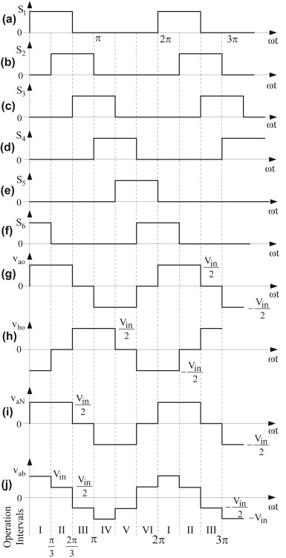

**(b) Waveforms**

**Fig. 3.23 Three phase 6 step 120 mode bridge inverter**

There are six modes of operation in each cycle, with Modes 1, 2 & 3 in the positive half-cycle and Modes 4, 5 & 6 in the negative half-cycle. The equivalent circuits in each of Modes 1, 2 & 3 are shown in Fig. 3.24

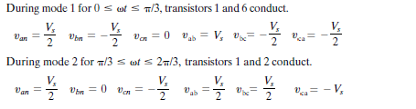

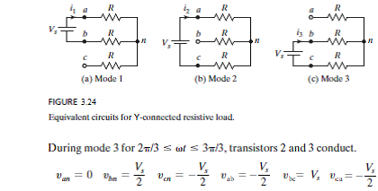

The equivalent circuits for Modes 4, 5 & 6 can be obtained from Modes 1, 2 & 3, respectively, by reversing the polarity of the supply Vs. Accordingly, all phase and line voltages for Modes 4, 5 & 6 will be the negative of the corresponding voltages for Modes 1, 2 & 3.

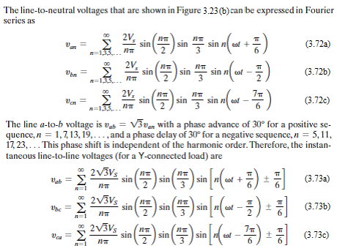



The rms value of the line-to-neutral output voltage can be obtained as:

VP = = = 0.4082Vs (3.74)

The rms value of the fundamental line-to-neutral output voltage can be obtained from Eq. (3.72) as:

VP1 = (3.75)

The rms value of the line-to-line output voltage can be obtained as:

VL =

= = 0.7071Vs (3.76)

The rms value of the fundamental line-to-line output voltage is:

VL1 = = 0.6752 Vs (3.77)

Thus it is seen that for 120º mode, the **line-to-line** output voltage is a **six step** waveform with amplitudes of +/- Vs/2 and +/-Vs, while the **phase** output voltage is a **quasi-square wave** with amplitude of +/- Vs/2 and pulse width of 120º.

This can be compared with 180º mode where it is seen that the **phase** output voltage is a **six step** waveform with amplitudes of +/- Vs/3 and +/-2Vs/3, while the **line-to-line** output voltage is a **quasi-square wave** with amplitude of +/- Vs and pulse width of 120º.

**Three phase 6 step 180 & 120 mode bridge inverters**

**A. Utility Factor, output current, switch current and output power**

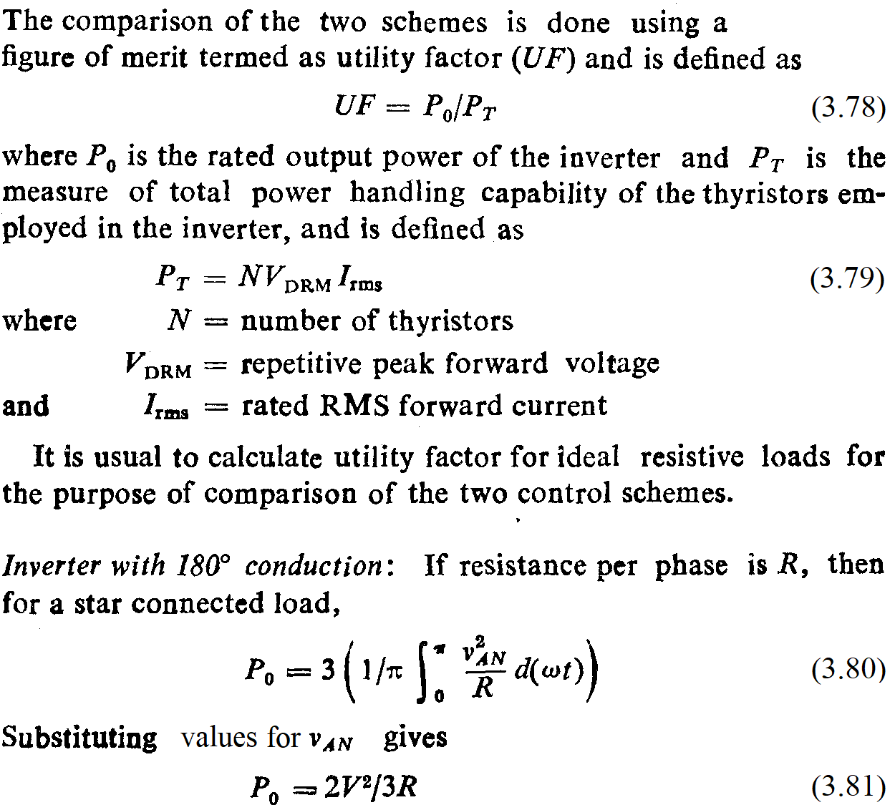

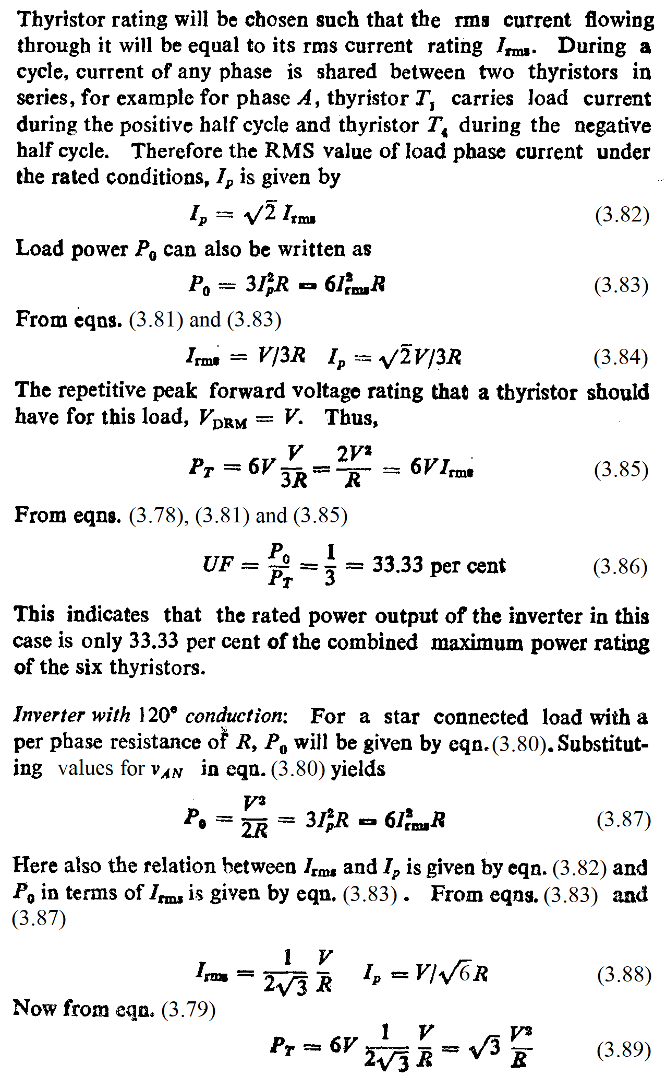

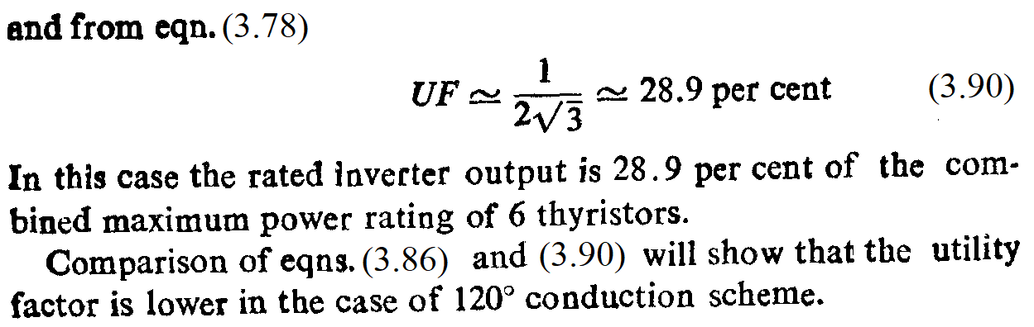

**B. Summary of expressions for 180º and 120º modes**

|  |  |  |  |
| --- | --- | --- | --- |
| **Sr. No.** | **Parameter** | **180º** | **120º** |
| 1 | Line-to-line waveform | Quasi-square, amplitude Vs, pulse width 120º | 6 step, step amplitudes Vs/3, 2Vs/3 |
| 2 | Line-to-neutral waveform | 6 step, step amplitudes Vs/2, Vs | Quasi-square, amplitude Vs/2, pulse width 120º |
| 3 | VL rms | $\sqrt{\frac{2}{3}}$ Vs | Vs |
| 4 | VL1 rms | $\frac{\sqrt{6}}{π}$ Vs | Vs |
| 5 | VP rms | $\frac{\sqrt{2}}{3}$ Vs | Vs |
| 6 | VP1 rms | $\frac{\sqrt{2}}{π}$ Vs | Vs |
| **Sr. No.** | **Parameter** | **180º** | **120º** |
| 7 | IP rms = IL rms (for balanced star R load) | VP /R | VP /R |
| 8 | IP1 rms = IL1 rms (for balanced star R load) | VP1 /R | VP1 /R |
| 9 | ISW rms | VP /R) | VP /R) |
| 10 | Po average | $\frac{2V_{s}^{2}}{3R}$ | $$\frac{\sqrt{3}V_{s}^{2}}{R}$$ |

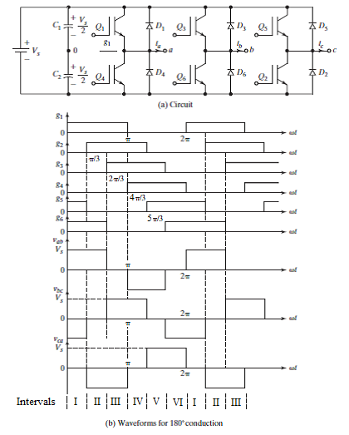

**Fig. 3.20 Three phase 6 step 180 mode bridge inverter**

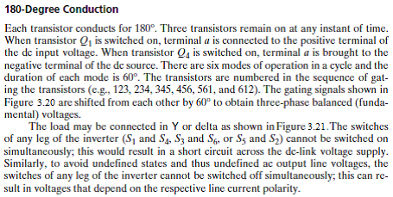

**RY = RΔ/3**

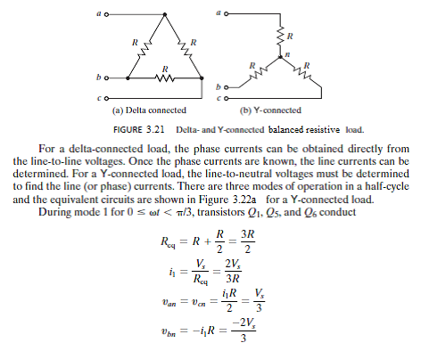

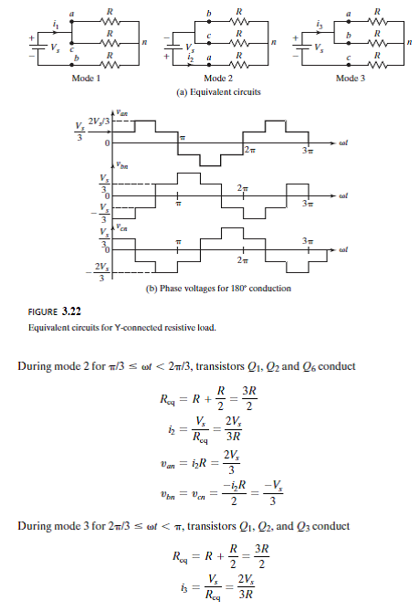



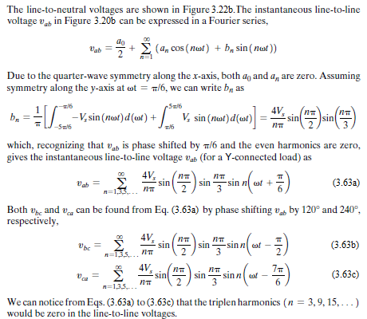

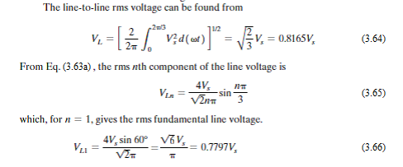

The line-to-neutral voltages in Figure 3.22 can be expressed in a Fourier series as:



$$v_{an}=\sum_{n=1,5, 7…}^{∞}{\frac{2V_{s}}{nπ}\sin{nωt}} (3.67)$$

$$v_{bn}=\sum_{n=1,5,7…}^{∞}{\frac{2V_{s}}{nπ}\sin{ \left(n\left(ωt-\frac{2π}{3}\right)\right) }} (3.68)$$

$$v_{cn}=\sum_{n=1,5,7…}^{∞}{\frac{2V_{s}}{nπ}\sin{ \left(n\left(ωt+\frac{2π}{3}\right)\right) }} (3.69)$$

The rms value of the fundamental line-to-neutral voltage can also be obtained from the corresponding line-to-line voltage as:

VP1 = = 0.4502Vs (3.71)

Thus it is seen that for 180º mode, the **line-to-line** output voltage is a **quasi-square wave** with amplitude of +/- Vs and pulse width of 120º, while the **phase** output voltage is a **six step** waveform with amplitudes of +/- 1/3Vs and +/- 2/3Vs.

This can be compared with 120º mode where it is seen that the **phase** output voltage is a **quasi-square wave** with amplitude of +/- Vs/2 and pulse width of 120º, while the **line-to-line** output voltage is a **six step** waveform with amplitudes of +/- Vs/2 and +/-Vs.

**Waveform symmetries for Fourier Analysis**

**1.** **Even symmetry**:

f(t) = f(-t) → bn = 0 for all n → **only DC and cosine terms present**

or f(ωt) = f(-ωt)

hence a0 =

**a0 = (1.1)**

an =

or an =

**an = (1.2)**

**bn = 0 for all n**  **(1.3)**

**2.** **Odd symmetry**:

f(t) = -f(-t) → an = 0 for all n → **only sine terms present**

or f(ωt) = -f(-ωt)

hence bn =

or bn =

**bn = (2.1)**

**an = 0 for all n**  **(2.2)**

**3. Half-wave symmetry:**

f(t) = -f(t +/- T/2) → a0 , b0 = 0 for n = 0, 2, 4, 6 **...→ only odd terms**

**present**

or f(ωt) = -f(ωt +/- π)

**3.1. Even half-wave symmetry:** → **only DC and even cosine terms**

**present**

**a0 = (1.1)**

**an = (1.2)**

**n is even (2, 4, 6…)**

**bn = 0 for all n**  **(1.3)**

**3.2. Odd half-wave symmetry:** → **only odd sine terms present**

**bn = (2.1)**

**n is odd (1, 3, 5…)**

**an = 0 for all n**  **(2.2)**